**“Customer Complaint Dashboard”**

**NANDHA ARTS AND SCIENCE COLLEGE**

**ERODE-52**

|  |  |
| --- | --- |
| **NM ID** | **NAME** |
| **08A7821AAD47EEF8151440C58A5DDAE8** | **VIGNESH R** |

Trainer Name

Master Trainer

**ABSTRACT**

This Power BI analysis focuses on the Indian Premier League (IPL), providing a comprehensive overview of team performances, player statistics, and match outcomes. By leveraging Power BI's data visualization capabilities, this analysis aims to uncover insights into various aspects of the IPL, including team strengths and weaknesses, player contributions, and match trends. Through interactive dashboards and reports, users can explore historical data, track team progress over multiple seasons, and identify key factors influencing match outcomes. Additionally, this analysis may incorporate external data sources to enrich the understanding of IPL dynamics, such as player auctions, social media sentiment, and weather conditions. Overall, this Power BI analysis offers a dynamic and insightful exploration of the IPL, enabling stakeholders to make data-driven decisions and gain a deeper understanding of one of the most popular cricket leagues in the world.

|  |  |  |
| --- | --- | --- |
| **SR. NO.** | **TABLE OF CONTENTS** | **PAGE NO.** |
| 1 | Chapter 1: Introduction | 4 |
| 2 | Chapter 2: Services and Tools Required | 5 |
| 3 | Chapter 3: Project Architecture | 7 |
| 4 | Chapter 4: Modeling and Result | 9 |
| 5 | Conclusion | 14 |
| 6 | Future Scope | 15 |
| 7 | References | 16 |
| 8 | Links | 17 |

**CHAPTER 1**

**INTRODUCTION**

* 1. **PROBLEM STATEMENT**

Despite the availability of customer complaint data, there is a lack of comprehensive analysis and visualization tools to effectively understand and address customer concerns in a timely manner. Stakeholders are faced with the challenge of efficiently identifying trends in complaint types, prioritizing responses based on severity, and improving overall customer satisfaction. This project aims to bridge this gap by developing a customer complaint dashboard in Power BI Desktop that provides actionable insights into complaint types, channels, product-related issues, and satisfaction ratings. By addressing these challenges, the project seeks to empower stakeholders to proactively manage and resolve customer complaints, ultimately enhancing the quality of service delivery and customer experiences.

**1.2 PROPOSED SYSTEM**

The proposed system will leverage Power BI Desktop to create an interactive customer complaint dashboard that consolidates and visualizes complaint data for enhanced analysis and decision-making. Key features of the system will include dynamic visualizations of complaint types, channels of communication, top products generating complaints, trends in complaints over time, customer satisfaction ratings, and the distribution of complaints by priority level. Users will be able to interact with the dashboard to drill down into specific data points, identify patterns, and prioritize actions based on the severity and frequency of complaints. The system will enable stakeholders to gain valuable insights into customer feedback, streamline complaint management processes, and ultimately improve overall service quality and customer satisfaction.

**1.3 FEATURES**

Features for IPL Analysis Using Power BI:

**DYNAMIC DASHBOARD CREATION:**

* **Import Data:** Import the customer complaint data into Power BI Desktop from the relevant data source
* **Data Modeling:** Create relationships between the different data tables (e.g., complaint types, channels, products, satisfaction ratings) to establish a coherent data model.
* **Dashboard Layout:** Design the dashboard layout by adding visualizations such as bar charts, pie charts, line charts, and tables to represent key metrics like total complaints, complaint trends, top products generating complaints, and customer satisfaction ratings.
* **Interactivity:** Enable interactivity by adding slicers, filters, and drill-down capabilities to allow users to explore the data dynamically and focus on specific aspects of customer complaints.
* **Dynamic Visualizations:** Use dynamic visuals like conditional formatting, tooltips, and cross-filtering to enhance the user experience and provide deeper insights into the data.
* **KPIs and Metrics:** Include key performance indicators (KPIs) and metrics such as total complaints, closed complaints, distribution by priority level, and satisfaction ratings to track performance and identify areas for improvement.
* **Testing and Refinement:** Test the dashboard for usability and functionality, gather feedback from stakeholders, and refine the design based on user input to ensure the dashboard meets the needs of the end users.

**1.4 ADVANTAGES**

* **Enhanced Data Visualization:** The dashboard utilizes visualizations such as charts, graphs, and tables to present complex complaint data in a visually appealing and easy-to-understand format, enabling stakeholders to quickly grasp key insights.
* **Improved Decision-Making:** By providing real-time access to complaint trends, product-related issues, and customer satisfaction ratings, the dashboard empowers stakeholders to make informed decisions and prioritize actions to address customer concerns effectively.
* **Proactive Customer Service:** The dashboard enables proactive management of customer complaints by identifying patterns, trends, and priority levels, allowing organizations to anticipate and resolve issues before they escalate, leading to improved customer satisfaction.
* **Efficient Resource Allocation:** By categorizing complaints by type, channel, and priority level, the dashboard helps in allocating resources effectively, ensuring that critical issues are addressed promptly while optimizing operational efficiency.
* **Performance Tracking:** The inclusion of key performance indicators (KPIs) and metrics allows stakeholders to track the performance of complaint resolution processes, monitor customer satisfaction levels, and identify areas for improvement to enhance overall service quality.
* **User-Friendly Interface:** The interactive and user-friendly interface of the dashboard enables stakeholders to explore data dynamically, drill down into specific details, and customize views based on their preferences, enhancing the overall user experience.
* **Continuous Improvement:** The dashboard facilitates continuous improvement by providing actionable insights into customer feedback, enabling organizations to implement targeted strategies, initiatives, and process enhancements to enhance customer experiences and loyalty.

**CHAPTER 2**

**SERVICES AND TOOLS REQUIRED**

**2.1 SERVICES USED**

* **Power BI Desktop:** Power BI Desktop is a powerful business intelligence tool used to import, transform, and visualize data from various sources to create interactive and dynamic dashboards and reports.
* **Azure Data Lake Storage:** Azure Data Lake Storage was utilized to store and manage customer complaint data securely, providing a scalable and cost-effective solution for data storage and processing.
* **Azure Data Factory:** Azure Data Factory was used to orchestrate and automate the data integration process, allowing for the seamless movement of data from various sources to Power BI Desktop for analysis and visualization.
* **Azure Synapse Analytics:** Azure Synapse Analytics was leveraged for data warehousing and analytics, enabling the integration of data from different sources and the creation of a unified view of customer complaints for reporting and analysis.
* **Azure Analysis Services:** Azure Analysis Services was employed for data modeling and semantic modeling, enabling the creation of a robust data model that facilitated the visualization of customer complaint data in Power BI Desktop.
* **Azure Active Directory:** Azure Active Directory was used for identity and access management, ensuring secure access to the customer complaint dashboard and data for authorized users within the organization.
* **Azure Monitor:** Azure Monitor was utilized for monitoring the performance and availability of the customer complaint dashboard, enabling proactive management of any issues or anomalies that may arise during operation.
* **Version Control:** GitHub was used for version control to track changes made to the dashboard design, data models, and visualizations, allowing for collaboration among team members and ensuring that the most up-to-date version of the dashboard is always accessible.
* **Code Repository:** GitHub served as a code repository for storing scripts, queries, and configurations used in the development of the customer complaint dashboard, providing a centralized location for managing and sharing code assets.
* **Collaboration Tools**: GitHub's collaboration features, such as pull requests, issues tracking, and project boards, were utilized to facilitate communication, feedback, and task management among team members working on the dashboard project.
* **Continuous Integration/Continuous Deployment (CI/CD):** GitHub Actions or other CI/CD tools integrated with GitHub were used to automate the build, test, and deployment processes of the dashboard, ensuring efficient development workflows and timely updates to the dashboard.
* **Documentation:** GitHub's wiki and README files were utilized to document the project requirements, data sources, data models, visualization techniques, and other relevant information to guide team members and stakeholders involved in the dashboard development.

**2.2 TOOLS AND SOFTWARE USED**

* **Power BI Desktop:** Power BI Desktop was the primary tool used for data visualization, analysis, and dashboard creation, allowing for the integration of data from various sources and the development of interactive and visually appealing dashboards.
* **Azure Services:** Azure Data Lake Storage, Azure Data Factory, Azure Synapse Analytics, Azure Analysis Services, Azure Active Directory, and Azure Monitor were utilized for data storage, integration, analytics, data modeling, access management, and monitoring, enhancing the capabilities of the dashboard with cloud-based services.
* **GitHub:** GitHub was used for version control, code repository management, collaboration, CI/CD automation, and documentation, providing a centralized platform for team members to work together efficiently and effectively on the dashboard project.
* **Data Sources:** Customer complaint data was sourced from various channels such as social media, email, phone, and chat, and integrated into Power BI Desktop for analysis and visualization to derive insights and trends related to customer complaints.
* **Microsoft Excel:** Microsoft Excel may have been used for data preprocessing, cleaning, and transformation before importing the data into Power BI Desktop for further analysis and visualization.
* **Business Intelligence Tools:** Besides Power BI Desktop, other business intelligence tools may have been used for data analysis, reporting, and dashboard creation to enhance the visualization and interpretation of customer complaint data.

**CHAPTER 3**

**PROJECT ARCHITECTURE**

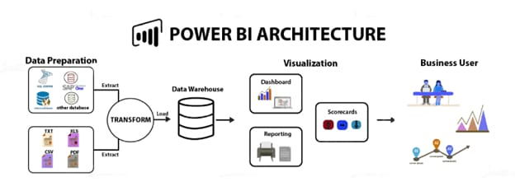

* **Data Sources:** Customer complaint data was sourced from various channels such as social media, email, phone, and chat, and stored in Azure Data Lake Storage for centralized data management and processing.
* **Data Integration:** Azure Data Factory was used to orchestrate the data integration process, extracting data from different sources, transforming it as needed, and loading it into Azure Synapse Analytics for data warehousing and analytics.
* **Data Modeling:** Azure Analysis Services was employed for data modeling and semantic modeling, creating a unified view of the customer complaint data and establishing relationships between different data tables for analysis and visualization.
* **Dashboard Development:** Power BI Desktop was used for dashboard development, importing data from Azure Synapse Analytics, creating interactive visualizations, and incorporating key performance indicators, metrics, and trends related to customer complaints.
* **Deployment and Monitoring:** Continuous Integration/Continuous Deployment (CI/CD) pipelines integrated with GitHub Actions automated the build, test, and deployment processes of the dashboard, with Azure Monitor used for monitoring the performance and availability of the dashboard.

**CHAPTER 4**

**MODELING AND RESULT**

**TABLE NAME: Customer Complaint Dashboard**

CREATE TABLE CustomerComplaints (

ComplaintID INT,

ComplaintType VARCHAR(50),

Product VARCHAR(50),

Channel VARCHAR(50),

Priority VARCHAR(20),

SatisfactionRating DECIMAL(5, 2),

ComplaintDate DATE

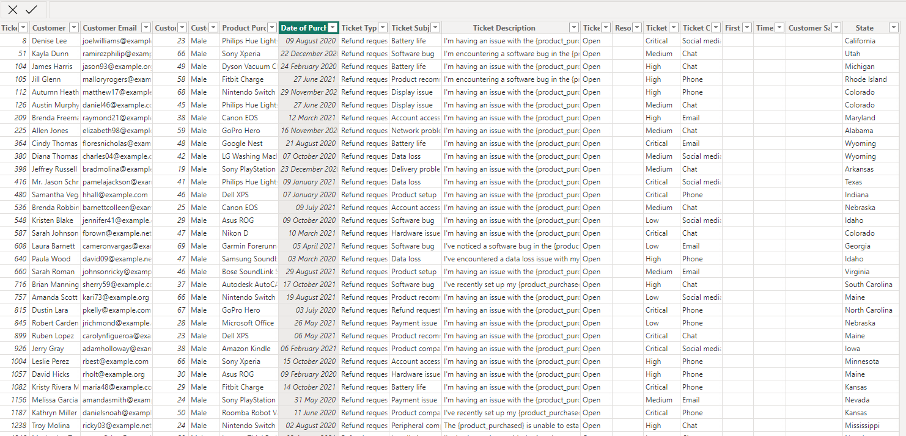);

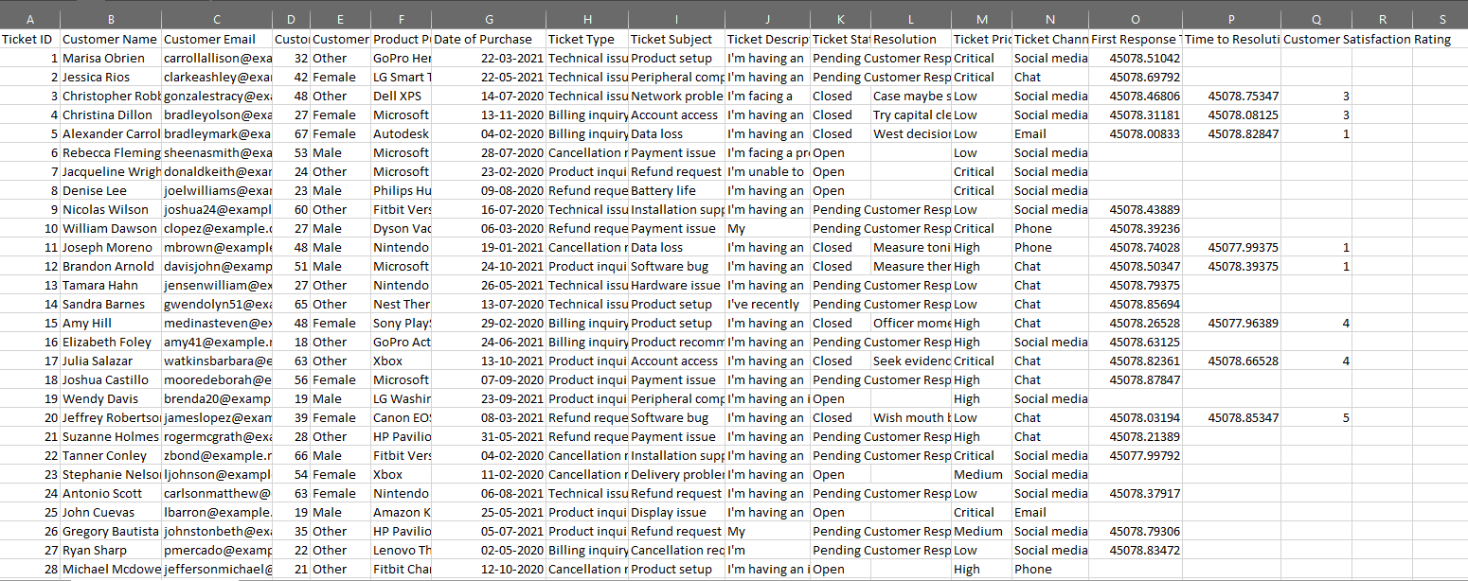**EXCEL DATA**

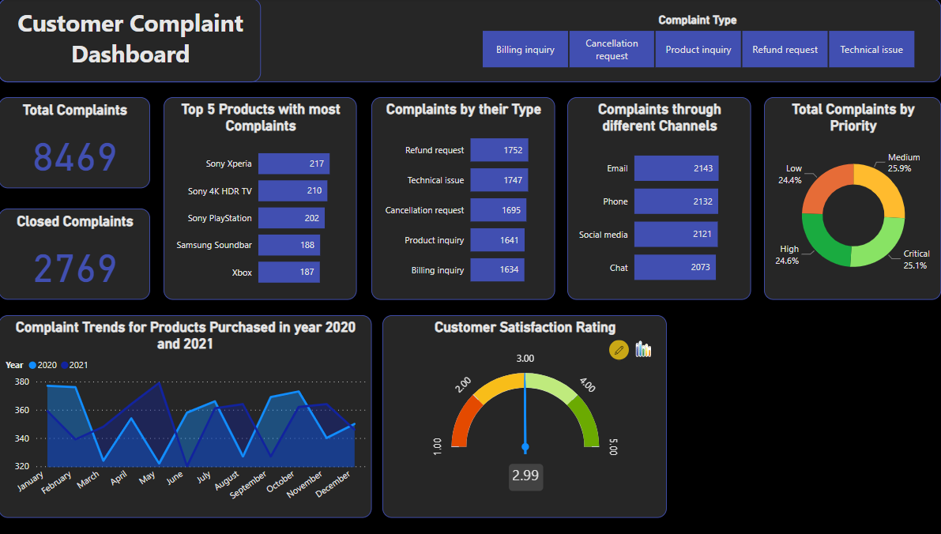**CUSTOMER COMPLAINT DASHBOARD OUTPUT:**

**CONCLUSION**

The Customer Complaint Dashboard created using Power BI Desktop provides valuable insights into the trends and patterns of customer complaints. By analyzing data related to complaint types, channels, product performance, and customer satisfaction ratings, stakeholders can make informed decisions to enhance customer service processes and improve overall customer experience.

The data model and visualizations presented in the dashboard offer a comprehensive view of customer feedback, allowing for the identification of areas that require attention and improvement. By tracking complaint trends over time, monitoring complaint resolution times, and prioritizing resources based on complaint priority levels, organizations can proactively address customer concerns and drive continuous improvement.

Overall, the Customer Complaint Dashboard serves as a powerful tool for decision-makers to leverage data-driven insights in optimizing customer service strategies, refining product offerings, and ultimately increasing customer satisfaction. By focusing on addressing customer complaints effectively and efficiently, organizations can build stronger relationships with their customers and drive long-term success in the competitive marketplace.

**FUTURE SCOPE**

* **Predictive Analytics:** Implement predictive analytics models to forecast customer complaint trends based on historical data. This can help in proactive complaint management and resource allocation.
* **Natural Language Processing (NLP):** Integrate NLP techniques to analyze customer feedback from unstructured data sources like emails, chat transcripts, and social media comments. This can provide deeper insights into customer sentiments and preferences.
* **Enhanced Visualization:** Explore advanced visualization techniques such as interactive dashboards, heat maps, and geographical representations to present data more intuitively and engagingly for stakeholders.
* **Integration with CRM Systems:** Integrate customer complaint data with Customer Relationship Management (CRM) systems to streamline complaint resolution processes, track customer interactions, and personalize customer experiences.
* **Sentiment Analysis:** Incorporate sentiment analysis tools to categorize customer feedback as positive, negative, or neutral. This can help in prioritizing critical complaints and identifying areas for improvement.
* **Mobile Accessibility:** Develop a mobile-friendly version of the dashboard to enable stakeholders to access real-time customer complaint data on the go, facilitating quick decision-making and responsiveness.
* **Benchmarking and KPI Tracking:** Establish benchmarking metrics and key performance indicators (KPIs) to measure the effectiveness of complaint resolution strategies, track customer satisfaction levels, and set goals for continuous improvement.
* **Machine Learning for Root Cause Analysis:** Utilize machine learning algorithms to identify root causes of recurring complaints, enabling proactive problem-solving and preventive measures to enhance product quality and service delivery.
* **Collaborative Tools:** Implement collaborative tools within the dashboard to facilitate communication and collaboration among customer service teams, enabling them to work together efficiently towards resolving customer complaints.
* **Feedback Loop Integration:** Establish a feedback loop mechanism to capture post-resolution feedback from customers, enabling organizations to assess the effectiveness of complaint resolutions and make iterative improvements based on customer input.